**EnergySave**

**By Aditya Vinod Kumar (+919845920700) and Rishi Ravikumar (+919591900867)**

**Problem Statement -**

The aim of the challenge is to build Machine Learning models to create energy consumption profiles for household and identify probable areas to plug wastage of energy in the household.

**Trend -**

The Energy Star Rating functions as a Health Index for an appliance’s power consumption. Is there an application which predicts the energy star rating of appliances and provides analysis on the reasons for high energy wastage? No. Not all appliances come under the Energy Star Rating Programme and because of the same, there is currently no way for a consumer to predict the Rating. Servicing of an appliance becomes a costly method if no warranty exists on the product. Sometimes the user also realizes that there was no issue with the product, yet the appliance was given for servicing.

**Idea -**

Our application provides an accurate prediction of the energy star rating of the appliance and also gives the possible reasons for the high energy consumption benefitting the user in 2 ways - giving a better picture of the health of the appliance being used and recognizing the need for replacement or servicing.

**Impact -**

This information isn’t provided to the user without servicing the product. We provide this information free of cost, and also reduce the amount of time wasted in the initial servicing of the product. The data generated by our application can be sent to various non-profit organizations for better statistical analysis on the usage trends of appliances. This application publicizes the need for Energy Star Rating on most appliances and to buy appliances which have this rating.

**Flow -**

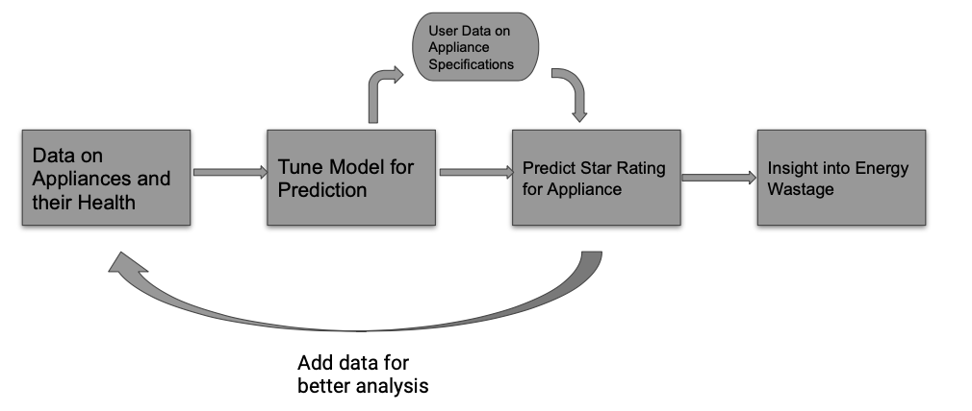

**Technologies Used -**

* The datasets are taken from - <https://data.gov.au/data/dataset/energy-rating-for-household-appliances>
* All the models have been trained using Python’s Sklearn library and the inferences and visualizations have been done using Jupyter Notebook
* The Backend of the application is done using Python’s Flask framework which includes all the routes for the REST API calls. The applications makes POST requests to the server and the server returns the predictions as the response.
* The Frontend is done using the React framework and the build is done using the Create-React-App Project from Facebook
* Refer README.md for more information on the Setup and Open Source Contribution for this project

**Scaling -**

Currently the project does not have a Business Model and is intended to be used as a free service. However some of the plans of scaling the project include -

* Increase flexibility on input data - lesser input for more accurate predictions using neural networks
* Convert to real-time data usage for the models, more personalized insights
* Provide information to product service centres or energy star organizations for better statistics